NAME: MARY ACHIENG OKOTH
REG NO: BIT/2024/74164
SCHOOL: COMPUTING AND INFORMATICS
PROGRAMME: MOBILE APPLICATION DEVELOPMENT
ACADEMIC YEAR: MAY/AUGUST
SEMESTER: YEAR 3 SEM 2
LECTURE: NYORO MICHAEL
PHONE:0707512632
week 1-5
SYSTEM DESIGN
Figure 1:Figma Wireframes and Prototypes
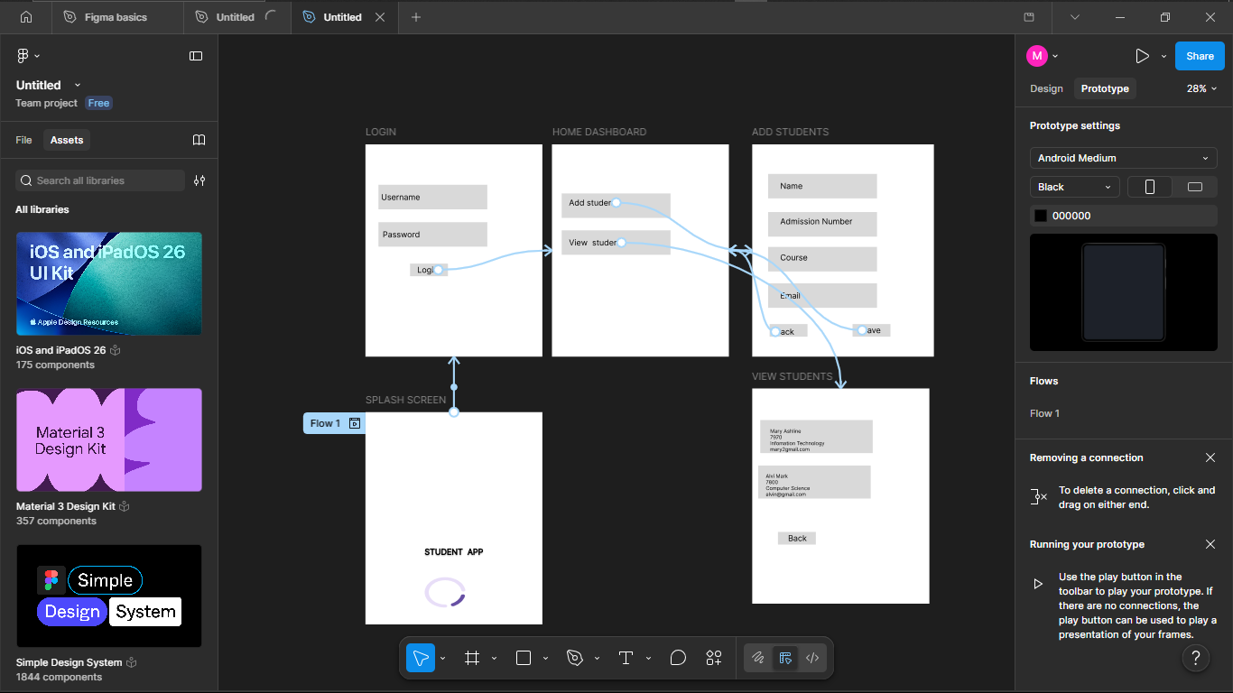

SYSTEM IMPLEMENTATION(Emulator)
Figure 2:Splash Screen

Figure 3:Login Screen
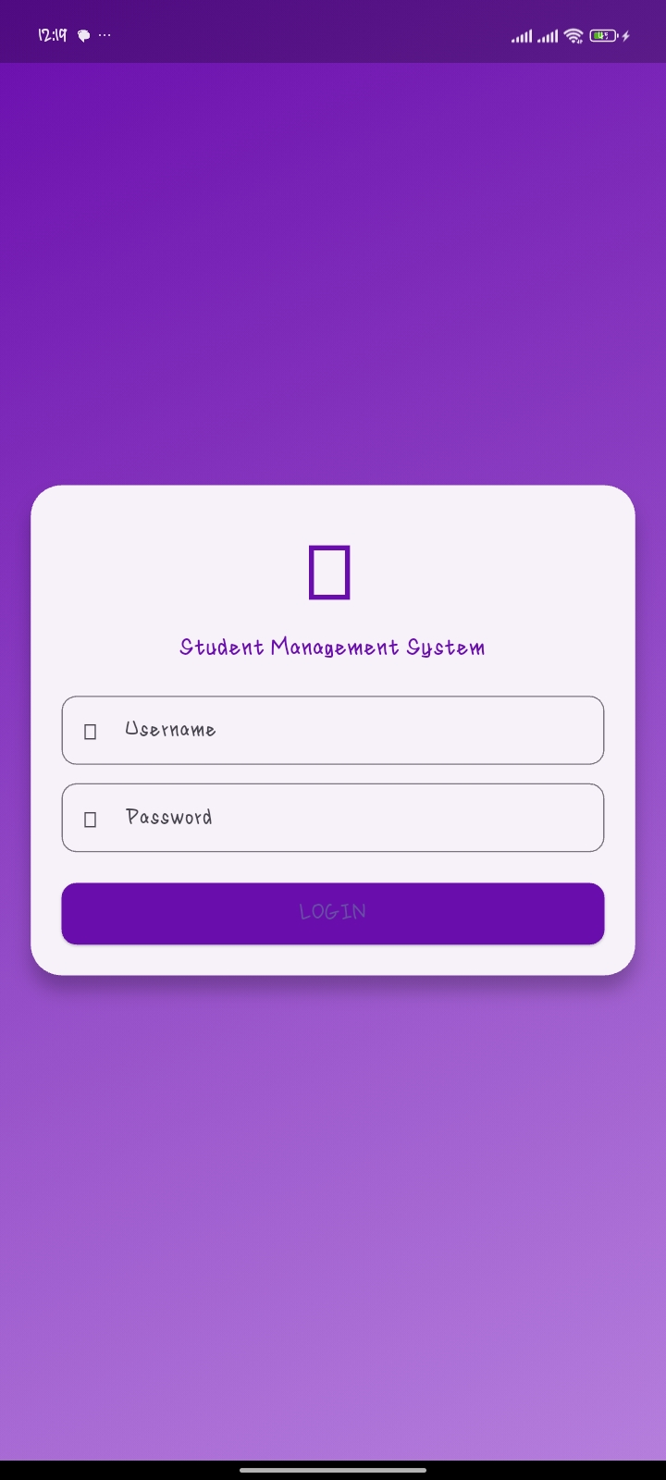

Figure 4:Home Dashboard Screen
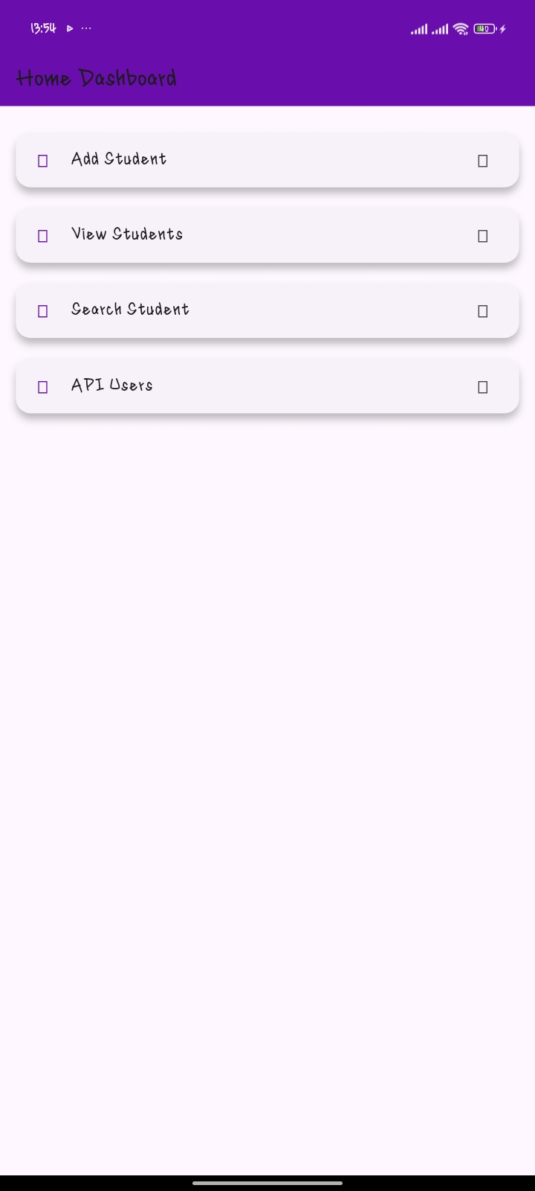
Figure 5:Add Student Screen
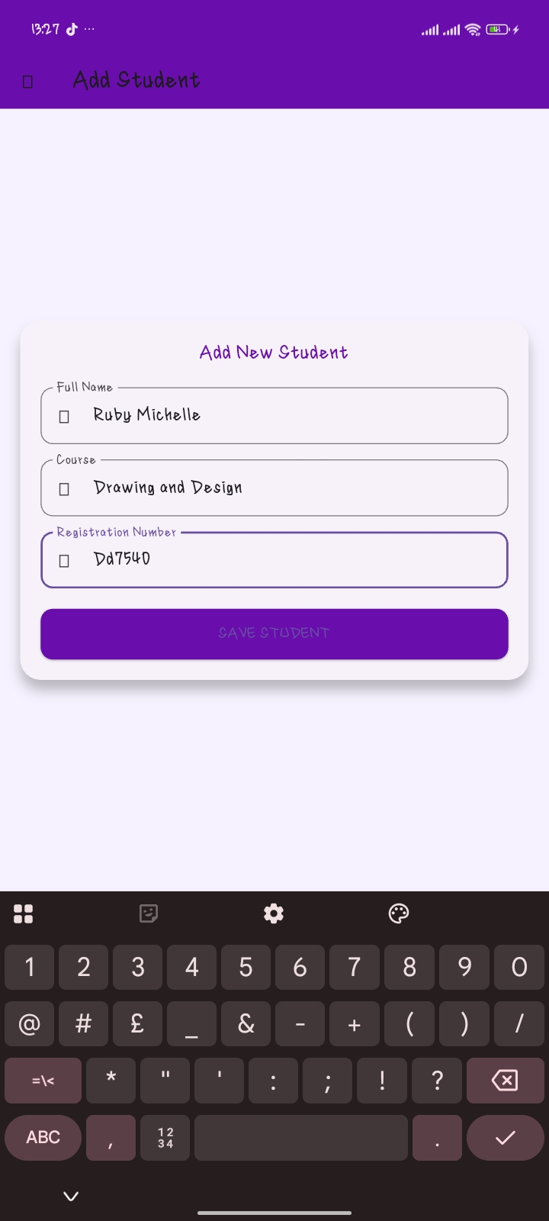
Figure 6:View Student Screen
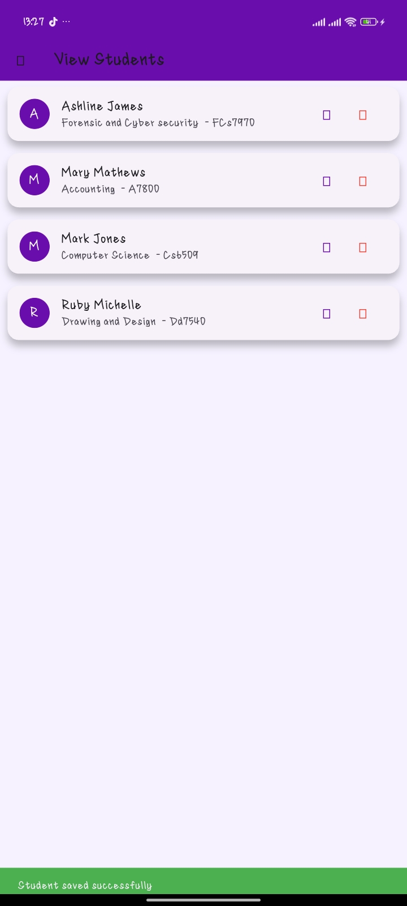

Figure 7:Edit Student Detail Screen
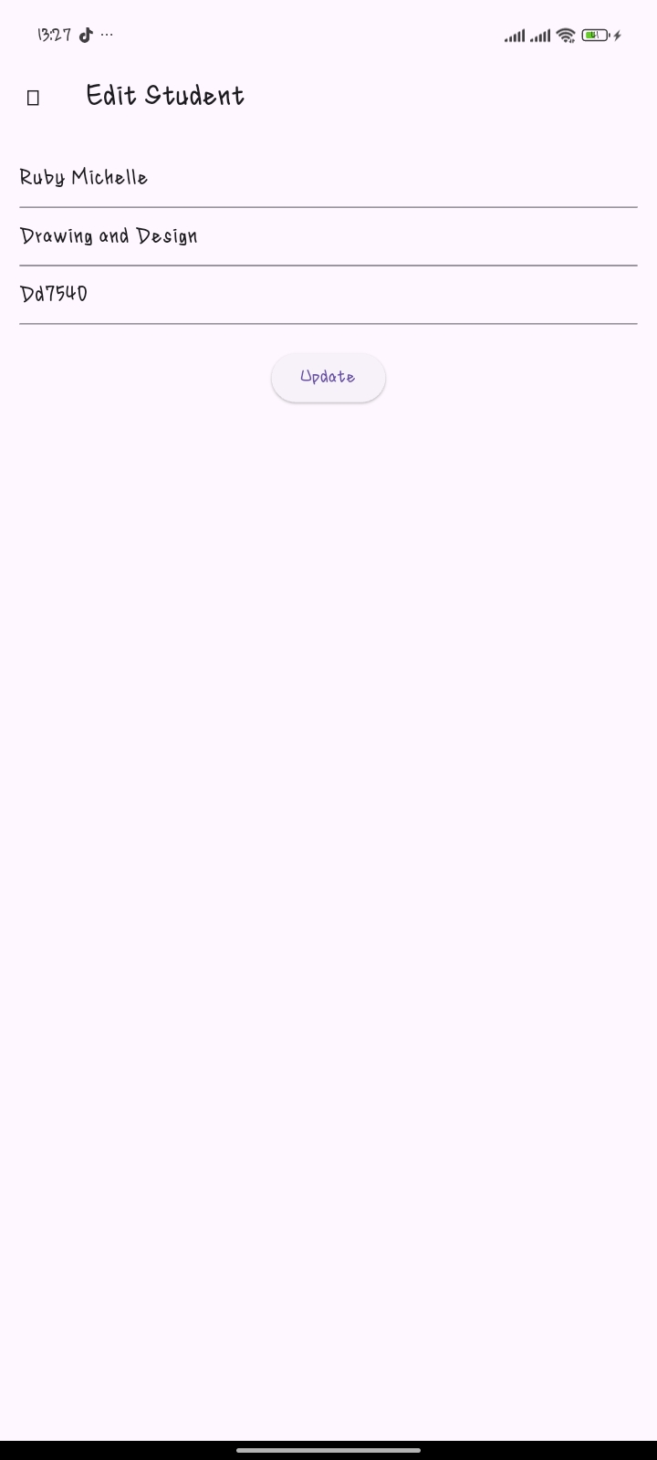

Figure 8:Search Student Screen
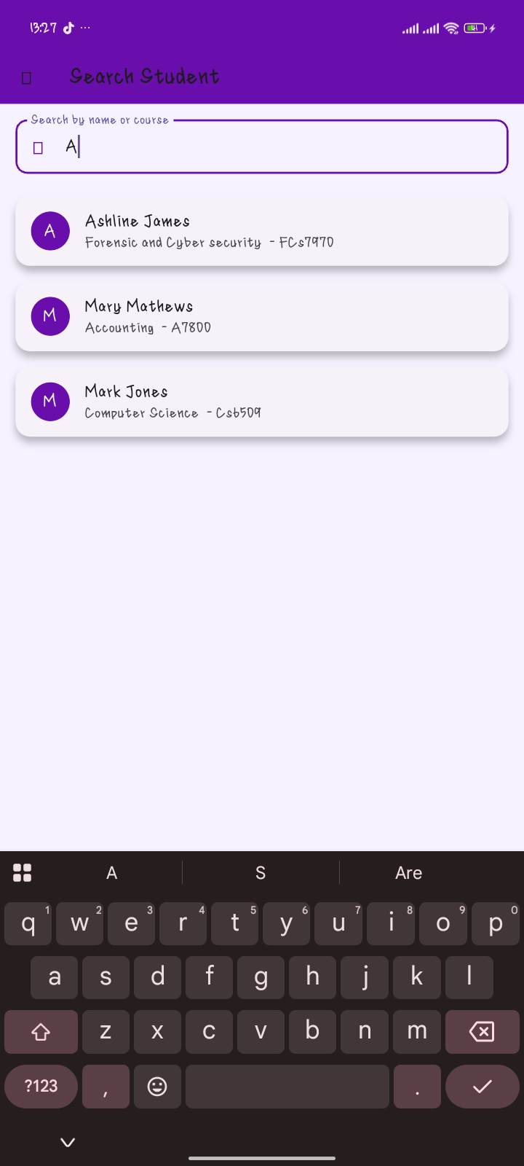

Figure 9:Fetched users from public REST API
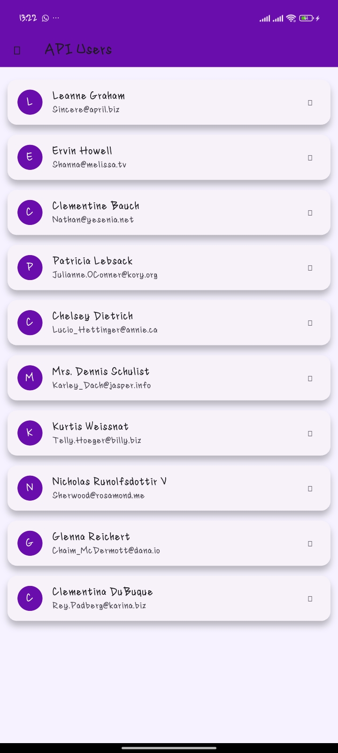

Figure 10:Error handling
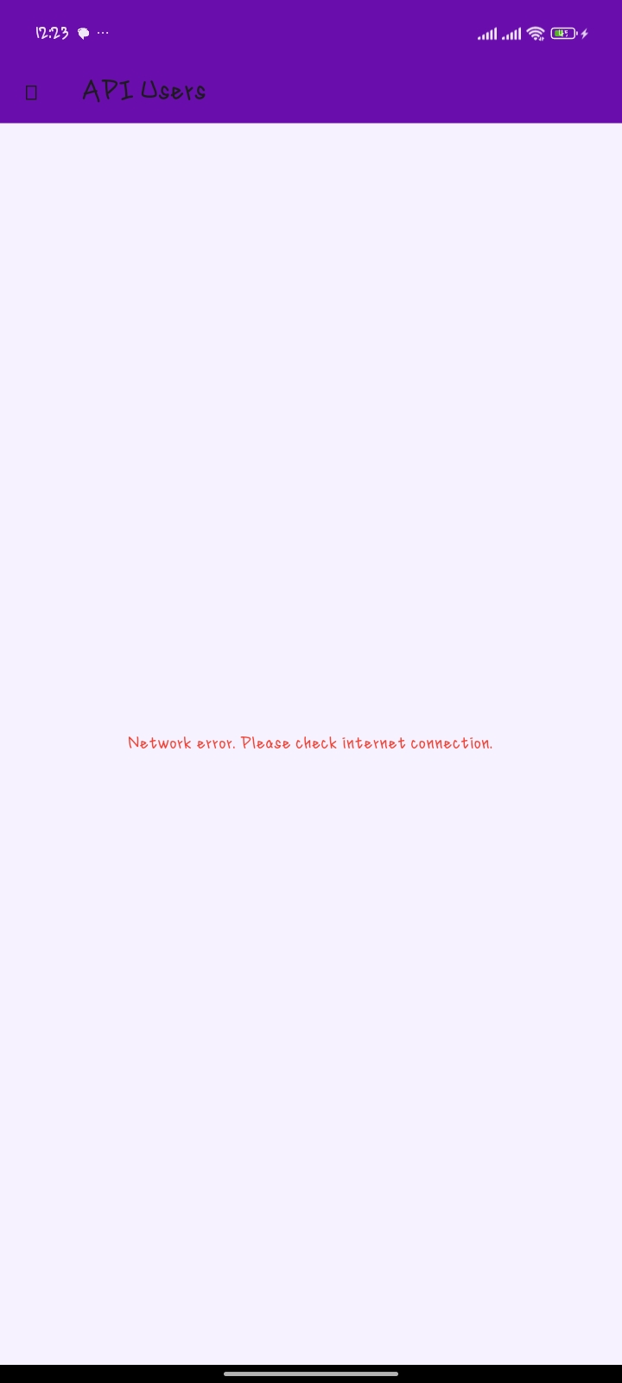

Why network is required

The application requires internet connection because it retrieves user data from a remote REST API. Without internet access, the app cannot communicate with the server or display updated records.
PERSONAL REFLECTION
Through this project, I gained practical experience in building a mobile application using Flutter. I learned about REST APIs, local storage, and navigation between screens. I also improved my debugging skills and understood how to handle errors in real-world applications.

